University of Azad Jammu and Kashmir

Name: Saghar Sarfaraz

Roll No: 2024-CET-31

Subject: Graphics Designing

Department: Software(CET)

Submitted To: Mam Fatima Khawaja

Task : Week two

Lab Task 1 – Create color Palette
Create a palette with 4 colors
Choose one primary color
Choose two supporting color
Add one acent color

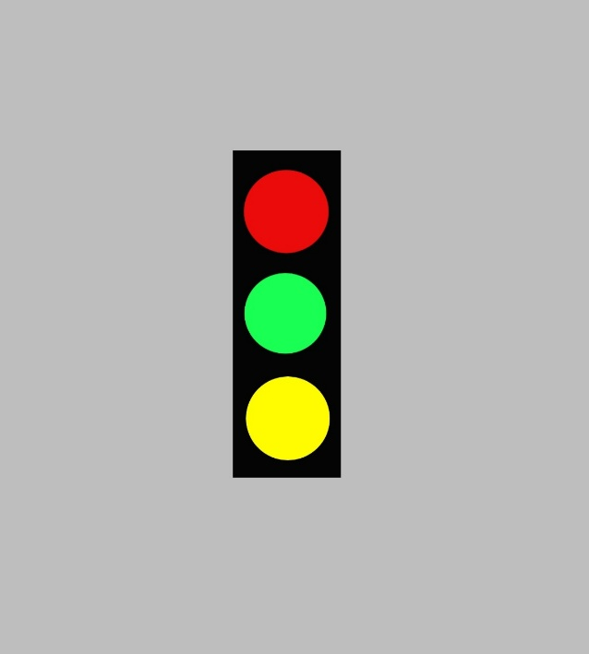

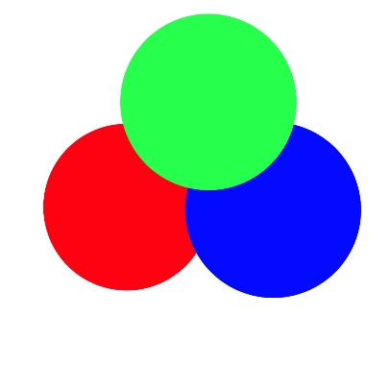

Lab Task two shapes Practice
Draw at least five shapes
Use circles rectangle and triangles
Apply color from your palette
Arrange shapes correctly

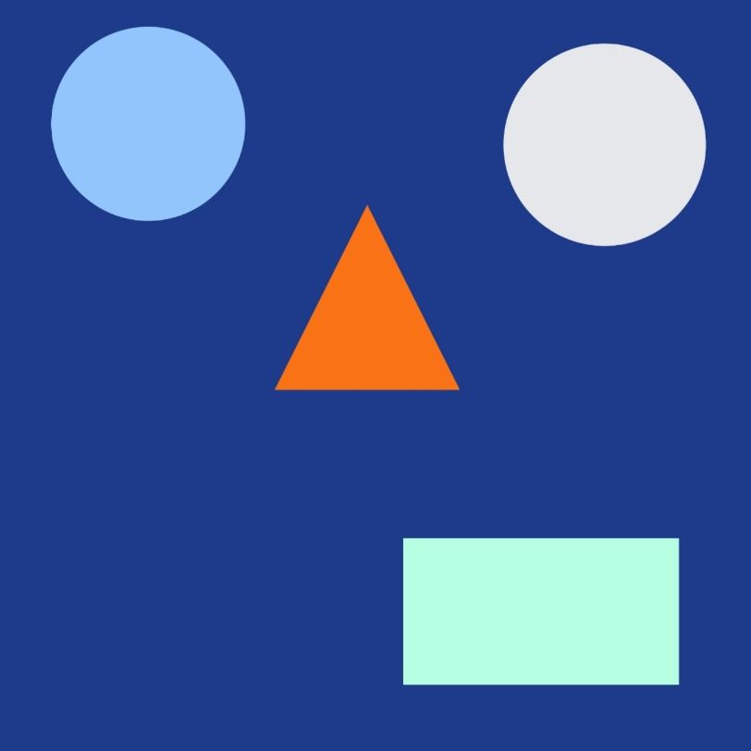

Lab Task 3 Abstract Composition
Create an abstract at work using shapes
Use your selected color palette
Focus on balance and contrast
Fill the Canva correctly

